1. Pre implemented conv-AE

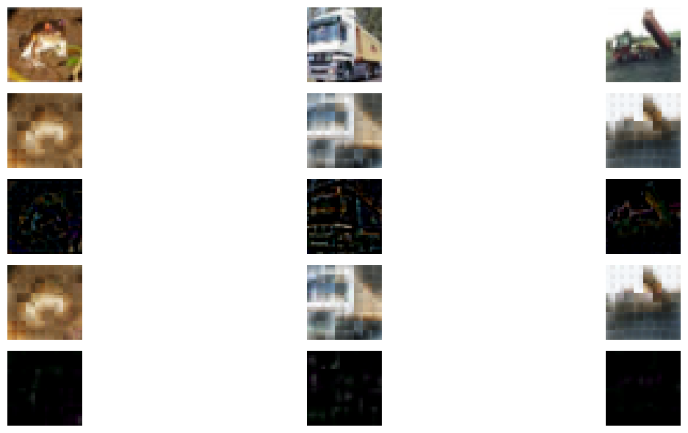

Figure: Naïve ConvAE. Up-down: origin, AutoEncoder output, residue 1

2 results of first naive conv RNN

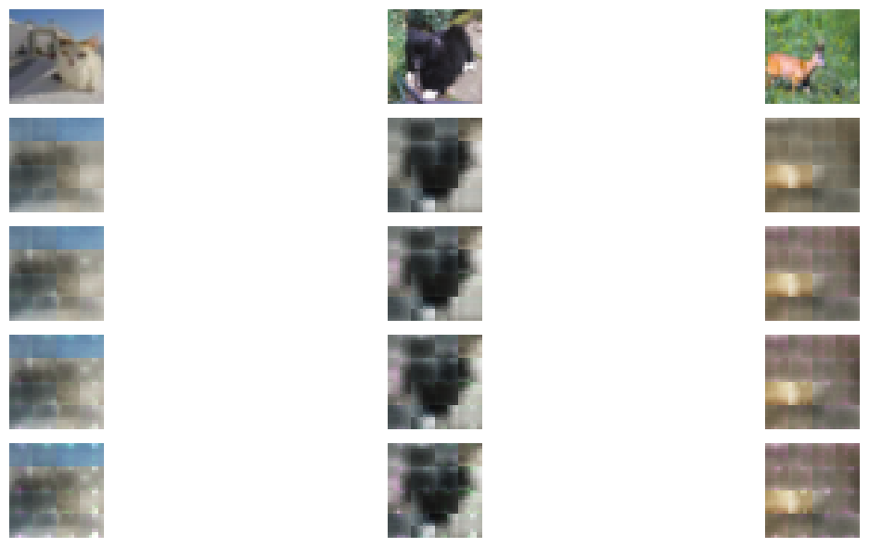

Figure 2: residual convAE, naïve preimplemented approach

It doesn’t go so well as a block for a residual network either.

1. Fully connected residual architecture

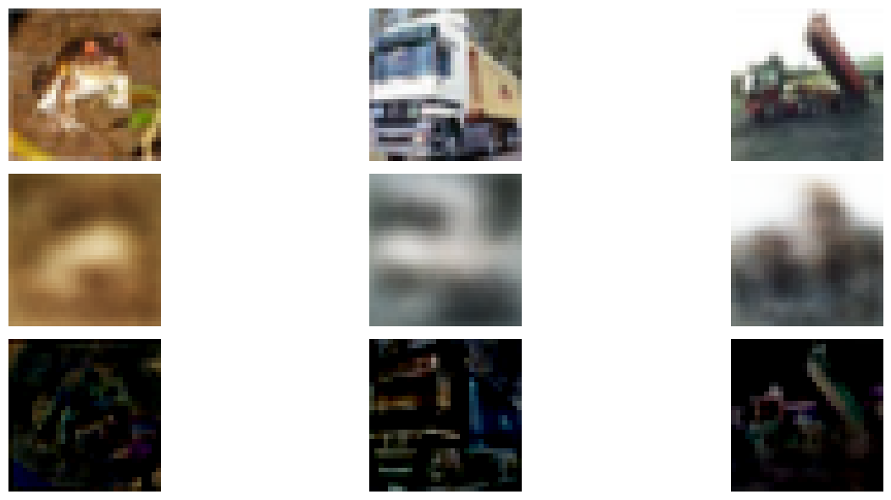

Figure 3:

These mildly superior results are achieved by using fc residual network

1. New improved conv-deconv AE

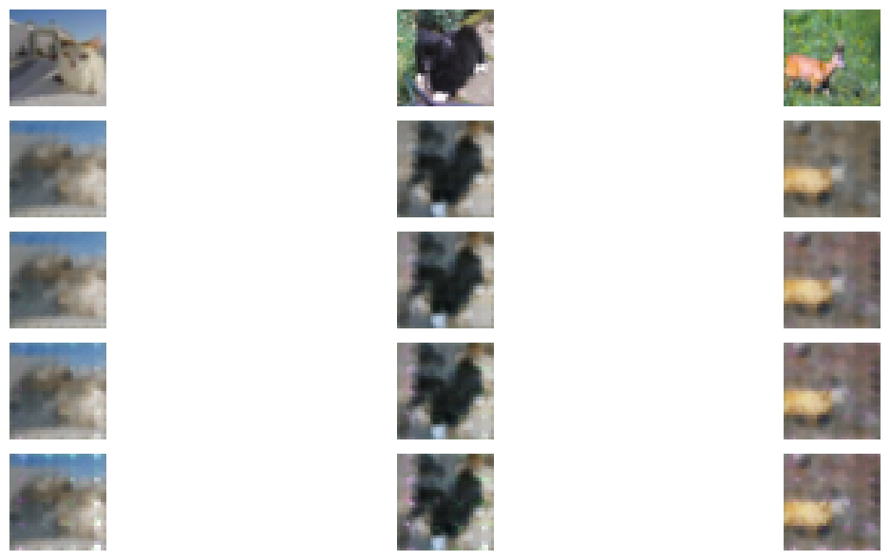



1. conv-deconv AE residual network

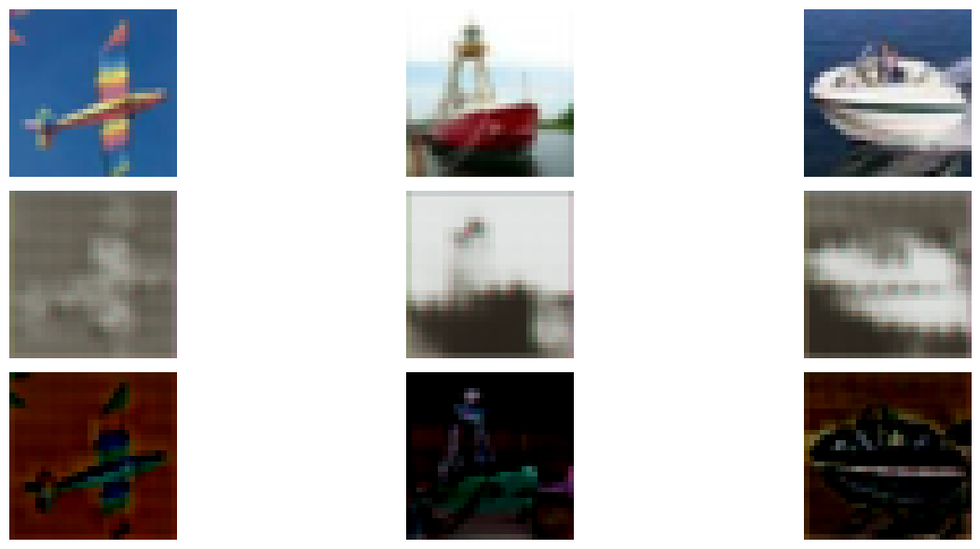

Figure 4 after a few seconds of training

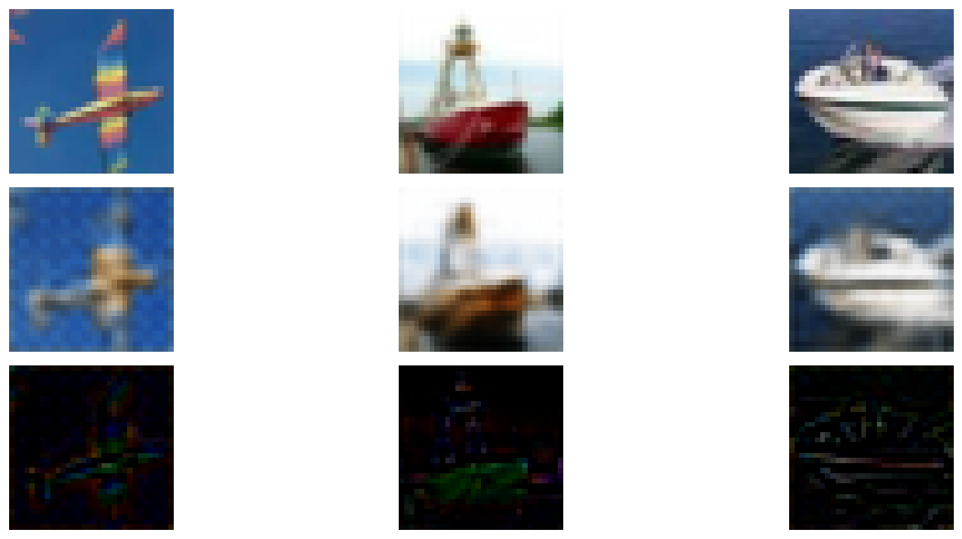

But the intermediate stages are rather useless: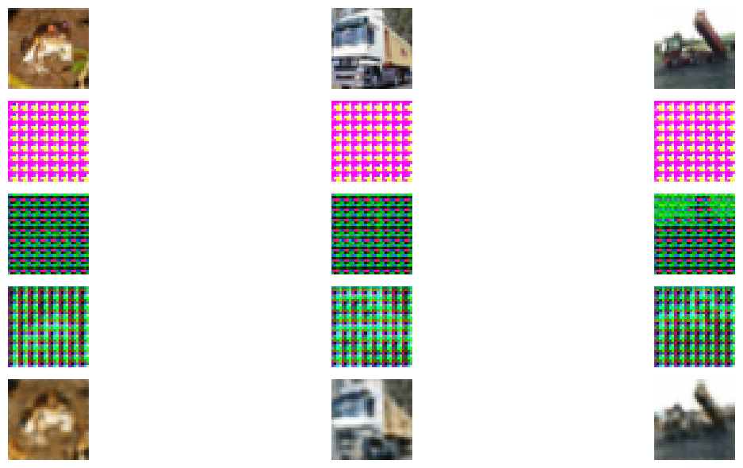

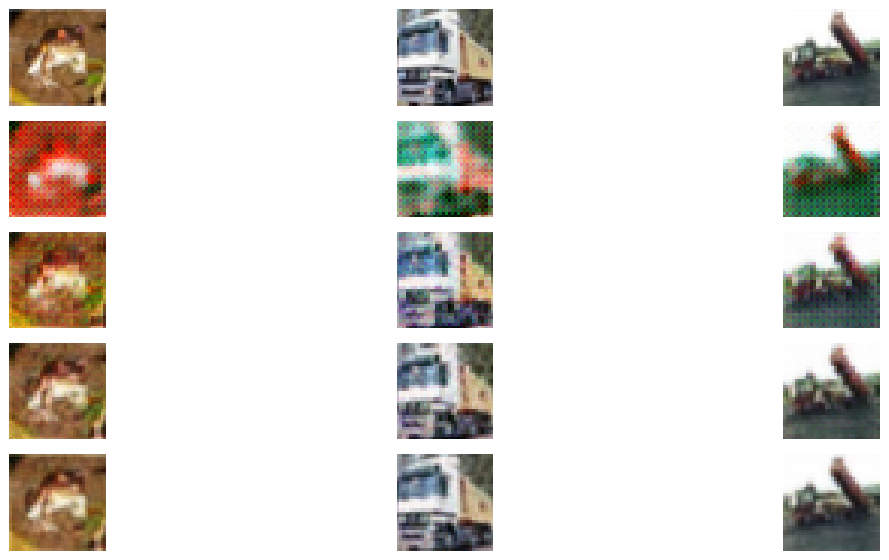

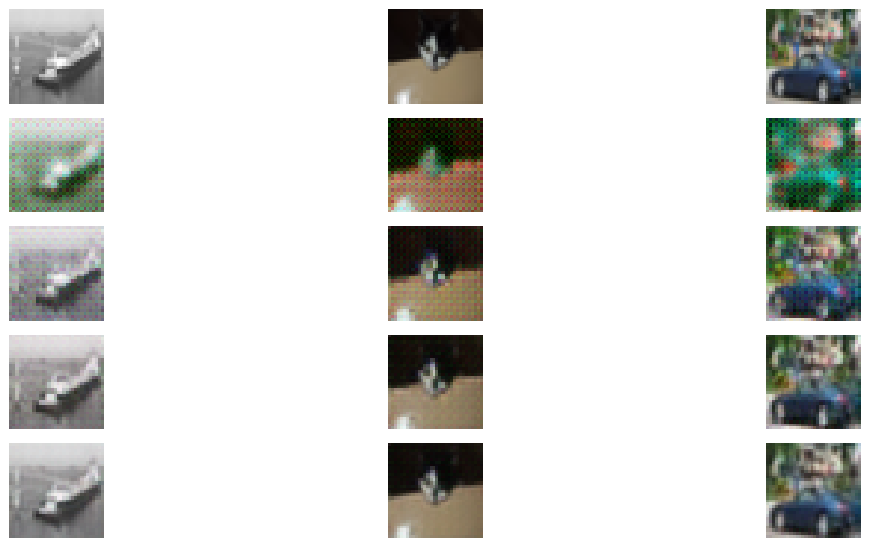

1. Binary layer

Adding the quantization layer does not currently achieve a satisfying result:

